BigFix Master Class 2026

Automated BigFix Performance and Configuration Analysis
Student Lab Guide

October 14, 2026


For more information
To learn more about BigFix, contact your HCLSoftware representative, HCL Business Partner, or visit www.BigFix.com.

About HCLSoftware
HCLSoftware, a division of HCLTech, develops, markets, sells, and supports software for digital transformation, data, analytics and insights, AI and automation, and enterprise security. HCLSoftware is the cloud-native solution factory for enterprise software and powers millions of apps at more than 20,000 organizations, including more than half of the Fortune 1000 and Global 2000 companies. HCLSoftware's mission is to drive ultimate customer success through relentless product innovation.
https://www.hcltechsw.com

© Copyright 2026 HCL

Produced in the United States of America.

All product names, trademarks and registered trademarks are property of their respective owners.

Contents
Lab Environment 5
Accessing Lab Environment 6
Master Class Diagnostics Workbench Lab Exercises 8
Overview 8
Before You Start 8
Exercise 1: Collecting the Data 9
Client Performance Counter Analysis 9
Deployment Information 11
Collect Client Performance Counter Analysis Data 13
Perfmon Counters 14
Exercise 2: Run the Workbench 17
Step 1: Folders and Run Details 17
Step 2: Choose the Modules 18
Step 3: Build the Outputs 19
Exercise 3: Read the Client Performance Output 22
Exercise 4: Read the Perfmon Analysis Output 24
Appendix A: FillDB Performance (Bonus Round) 26
Collect the logs 26
Run the module 27

Version Control

Release Date | Version | Authors | Comments
October 7, 2026 | 1.0 | Duncan McCalla | First version.
October 14, 2026 | 1.1 | Duncan McCalla | Added Windows launcher Unblock steps and a file Properties screenshot.

Lab Environment

The below table contains a summary of the VM images used in this lab guide:

Host Name | BigFix Components | OS | IP Address | Userid &  Password
BESFNDWINROOT | BigFix Windows based Server, Console, WebUI, and Client | Windows  2016 | 10.0.0.1 | Administrator  bigfixrocks
BESFNDWIN10 | BigFix Client, Console | Windows 10 | 10.0.0.2 | tecuser  bigfixrocks
BESFNDCENTOS | BigFix Client | CentOS7 | 10.0.0.3 | root bigfixrocks
All | BigFix Console creds |  |  | adminmo  B1gfixrocks
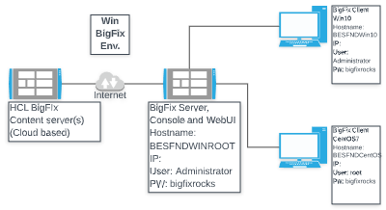

Accessing Lab Environment
The BigFix Lab environment is currently being hosted in Skytap’s (www.skytap.com). To access this environment, you will need the url, id, and password sent to your registered email address (this would be from Skytap.com). If you are a USA Federal customer – your instructor will provide you your credentials and access url(s).
Students will receive an email (this is the email address you provided when you registered for the course) from Skytap that contains the url to YOUR Skytap environment, the login id and password for this specific course. It will look something like this:
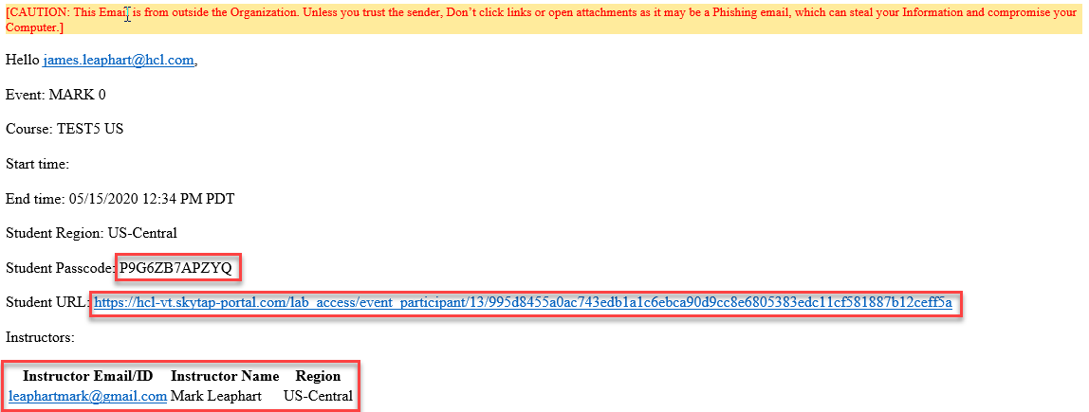
Click on the url provided in your email and provide your credentials (if asked). You will be taken into Skytap and you will see your provisioned environment.
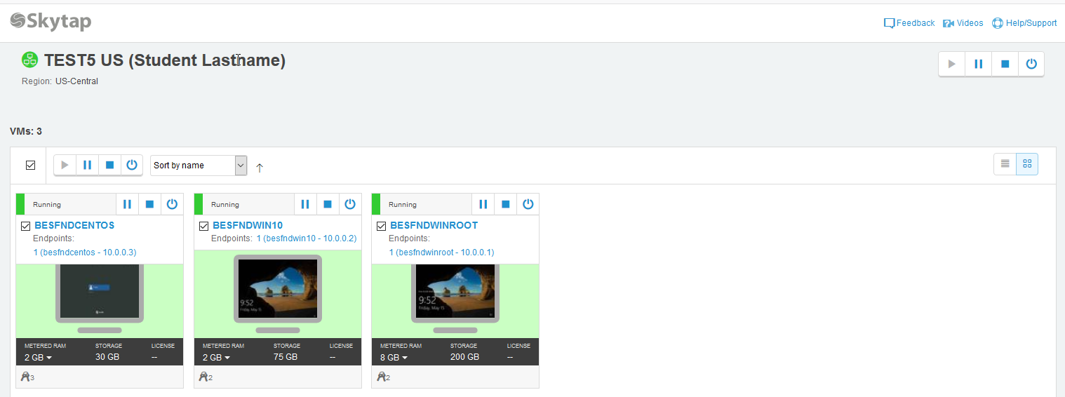
The vm’s provided here are accessible via your browser (rdp is not required). Click on a vm and your browser will present your vm:
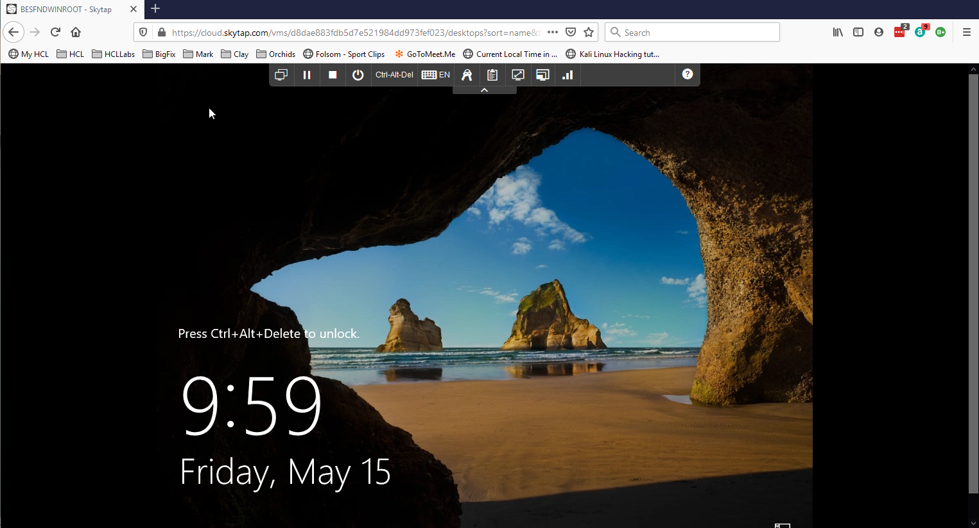
Now let’s look at the controls in the browser for this vm.
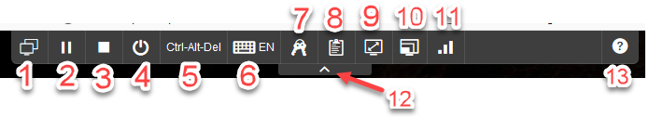
- Environment VM’s: View all vm’s in your environment or switch to another vm in your environment
- Suspend this vm
- Shutdown this vm
- Power options for vm - a) shutdown, b) reset, c) power off
- Ctrl-Alt-Del is passed to the vm
- Keyboard layout and or inject key combinations
- Credentials: operating system and applications in this vm
- VM Clipboard
- Fit to window
- Change video resolution
- Network Quality Indicator
- Hide this tool bar
- Help
When you open any of the Windows vm’s, always answer YES to the network connection question.

Master Class Diagnostics Workbench Lab Exercises

Overview
In this lab you will run the Master Class Diagnostics Workbench. You'll cover the two modules from the session today. The FillDB module is considered to be the Bonus Round and can be done if you finish the first two modules early OR you can do them at home/work later.
- Perfmon Analysis reviews the Windows performance of BigFix servers.
  - This can be any BigFix server (Web Reports, WebUI, etc.) and the SQL server(s) supporting the Platform. Although the focus, and established Perfmon thresholds, are typically on the Root Server and SQL Server.
  - The Workbench Perfmon Analysis module allows for the optional analysis of TWO Perfmon files in a single pass. Many customers will have a Perfmon file from their root server and another one from a SQL server.
- Client Performance Analysis reviews how quickly the BigFix clients evaluate content, respond to notifications, and how they are configured for performance.
The lab takes roughly 20 minutes…
Part | Time
Before You Start | 2 minutes
Exercise 1: Collect the Data | 5 minutes
Exercise 2: Run the Workbench | 5 minutes
Exercise 3: Read the Client Performance Output | 4 minutes
Exercise 4: Read the Perfmon Analysis Output | 4 minutes

NOTE: The FillDB exercise is waaaaay back in Appendix A. It should only take about 5 minutes if you choose to do it.

Before You Start
In production environments, the collection analysis needs several hours to catch as many clients as possible, the client tasks can take a while to run too. Perfmon is also a 24-hour capture.
In this lab you look at the analysis and run the tasks only to see what they do and how they work. The Workbench then builds from some lab sample data that ships with it.
Every module follows the same basic flow:
BigFix deployment Collection task Captured data Workbench module Mini Report
The Workbench is on the BigFix Server virtual machine in:
C:\Users\Administrator\Desktop\BigFixSrc\Master Class Diagnostics Workbench\
The sample data is in:
C:\Users\Administrator\Desktop\BigFixSrc\Master Class Diagnostics Workbench\SampleData\BigFix Master Class 2026\Results
NOTE: The Workbench is provided as-is to BigFix Master Class attendees only. It has no warranty or support. Do not redistribute it without approval.

Exercise 1: Collecting the Data
In this section, you will run the collection content for both modules from the BigFix Console. Exercise 2 will have you run it through the Workbench.

Client Performance Counter Analysis
In this exercise, you will simply enable an analysis that gathers various Client performance properties for use later by the Collect Client Performance Counter Analysis Data (2.0) task.
- Switch to the BigFix Server virtual machine – BESFNDWINROOT – and login to the machine using the following local administrator credentials:
Username: Administrator
Password: bigfixrocks
- Launch the BigFix console and login with the following Master Operator credentials:
Username: adminmo
Password: B1gfixrocks
- Select the All Content domain. Expand Sites > Custom Sites. Select the Performance and Config Analysis site.
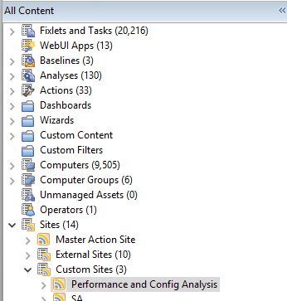
- Within that site, select Analyses then the BigFix Master Class -- Client Performance Counters - Basic (2.0) analysis. Review the Description to get familiar with what it does.
NOTE: Be sure to click the '+' sign next to Full Description & Deployment Notes to view all of the details.
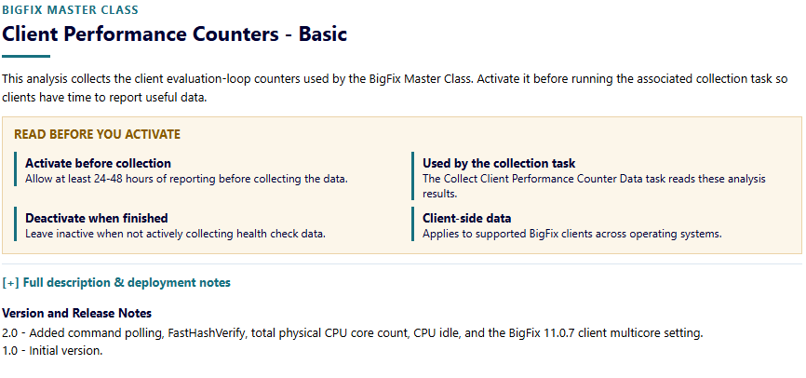
- Finally, in the top navigation pane, right-click on the BigFix Master Class -- Client Performance Counters - Basic (2.0) analysis and choose Activate. The status changes to "Activated Globally" (Globally because you are logged on as a Master Operator right now) and the Results tab will appear. Data will then start to show up gradually.

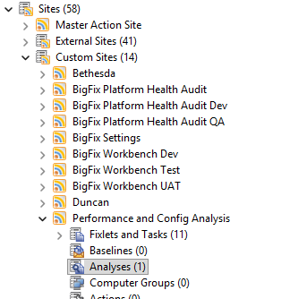
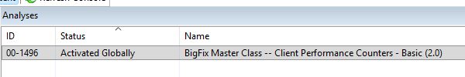
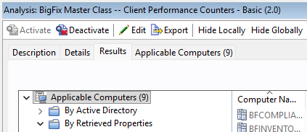

NOTE: In typical troubleshooting / health check scenarios, the analysis should be activated for 24 to 48 hours before you collect data. This is to ensure that you get as many computers reporting in as possible.

Deployment Information
Now you will run the task to collect deployment details. This is fairly large task and it retrieves a lot of useful information. In addition to the specific use case here of Client Performance analysis, this task is also used as a part of BigFix Health Checks, etc. and is a nice tool to have around. The Client Performance module requires these Deployment Information results. Exercise 2 uses the sample data, which already includes them.
- Still logged in to the BigFix Console, go to the Performance and Config Analysis site, select Fixlets and Tasks and then BigFix Master Class -- Collect Deployment Information (2.0). The task description opens in the work area. Spend a minute or so reviewing the details in the Description tab. Also take a minute to review the Actionscript and note the various parameters available to control files names, etc.
NOTE: Be sure to click the '+' sign next to Full Description & Deployment Notes to view all of the details.
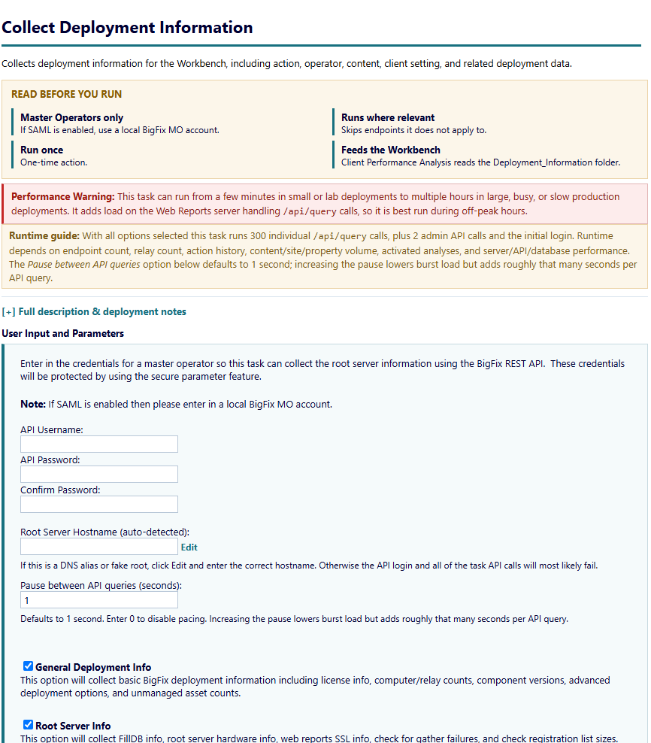

- Enter the console user name in API Username then enter the console password in API Password and Confirm Password fields. Leave Root Server Hostname as it is. Change it only for a DNS alias or fake root.
Username: adminmo
Password: B1gfixrocks

- Click Take Action. On the Target tab select the BESFNDWINROOT. Click OK.
- The action starts. You can review the BigFix client logs to see the action executing but, in the interest of time, do not wait for it to complete as this task queries a lot of information and can take a while to run. Continue on to the next section.

Collect Client Performance Counter Analysis Data
In this section, you will run an action that pulls the results from the analysis you activated in the Client Performance Counter analysis exercise. That data is retrieved and formatted in such a way as to make it useful for the Workbench's Client Performance module.
- Select BigFix Master Class -- Collect Client Performance Counter Analysis Data (2.0). The task description opens in the work area. Spend a minute or so reviewing the details in the Description tab.
NOTE: Be sure to click the '+' sign next to Full Description & Deployment Notes to view all of the details.
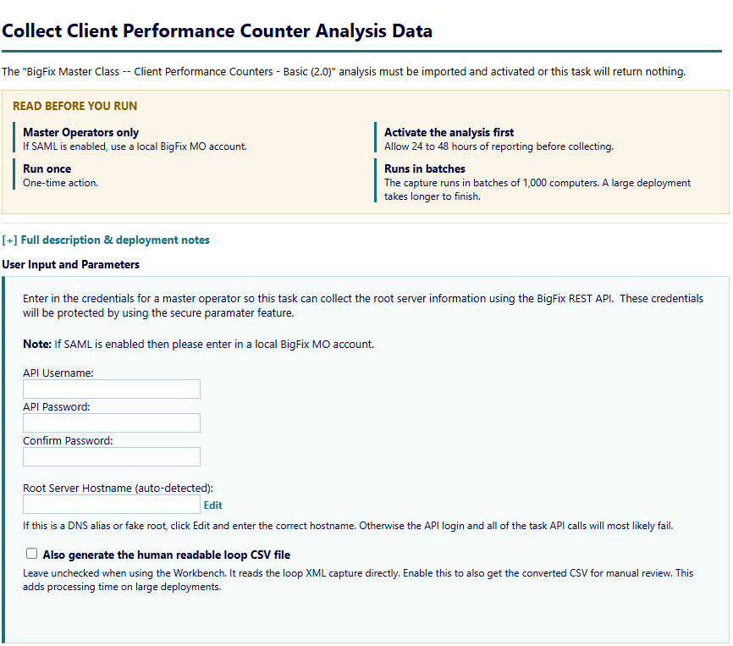

- Enter the console user name in API Username. Enter the console password in API Password and Confirm Password. Leave the Root Server Hostname as it is.
Username: adminmo
Password: B1gfixrocks
- Leave the "Also generate the human readable loop CSV file" option cleared.
- Click Take Action. On the Target tab select BESFNDWINROOT. Click OK.
- Wait for the action status to change to Completed. This should only take a few moments since there are only a small group of machines in the lab.

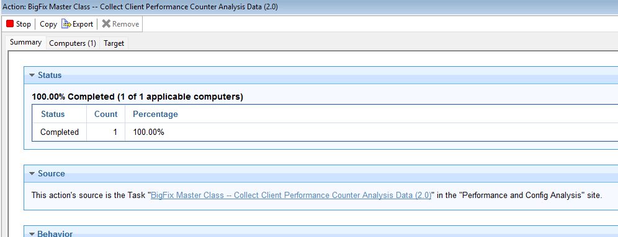

- You can view the data by opening the "C:\BigFix_Master_Class\Platform\Results\Client_Loop\" folder.

Perfmon Counters
In this lab you will run an action that configures and runs a custom Windows Perfmon data collector / counter set. The resulting file (.blg) is then used as the input for the Workbench's Perfmon Analysis module.
- Select BigFix Master Class -- Setup and Run Perfmon Counters (2.0). The task description opens in the work area. Spend a minute or so reviewing the details in the Description tab.
NOTE: Be sure to click the '+' sign next to Full Description & Deployment Notes to view all of the details.
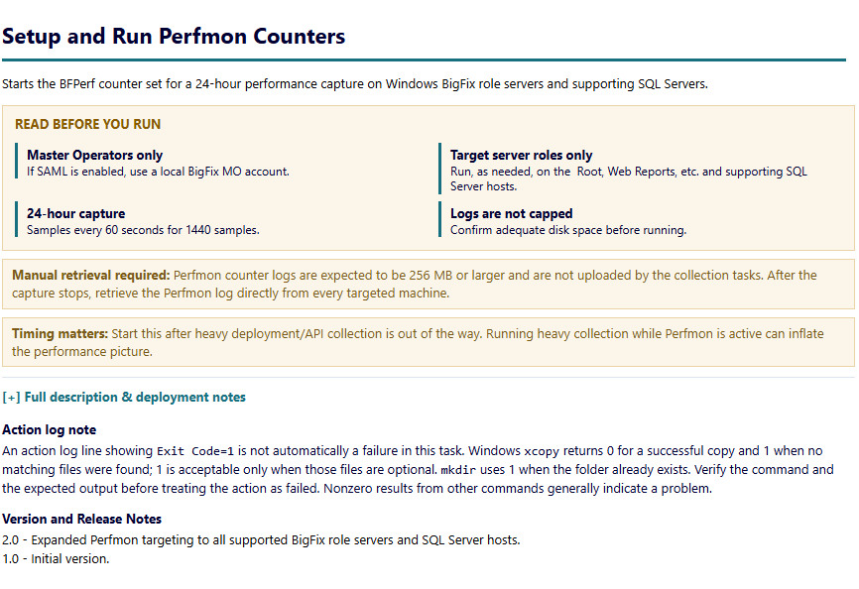
- Click Take Action. On the Target tab select BESFNDWINROOT. Click OK.
- Wait for the action status to change to Completed.
- Now let's verify the new "BFPerf" collector set is present and active in Performance Monitor.
- Using the Windows Start menu, type "perf" (for performance) and then open the Performance Monitor application.

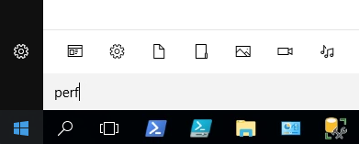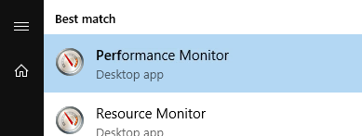

- In the Performance Monitor app, use the navigation tree and go to Data Collector Sets > User Defined. You should see "BFPerf" under that folder and it has a small green "play button" icon. This confirms that the new Perfmon counter set has been properly configured and is running.
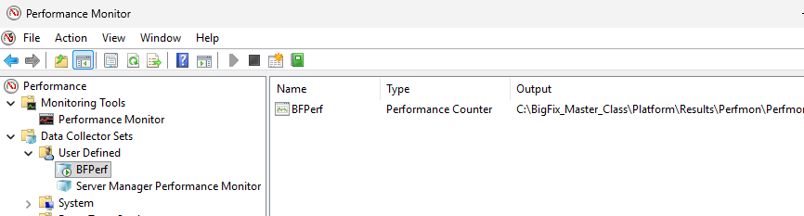
NOTE: The capture takes a sample every 60 seconds and stops on its own after 24 hours. You do not need to stop it. The Workbench uses the sample capture in Exercise 2.
- You can view the data by opening the "C:\BigFix_Master_Class\Platform\Results\Perfmon\" folder. Note that active Perfmon counter files will report a 0-size file until Perfmon capture is stopped.
You have now successfully completed Exercise 1.

Exercise 2: Run the Workbench
In this exercise you will run the two Workbench modules against the lab sample data.

Step 1: Folders and Run Details
- On the BigFix Server open C:\Users\Administrator\Desktop\BigFixSrc\Master Class Diagnostics Workbench\Launchers. Double-click Run Diagnostics Workbench.cmd. The Workbench opens on step 1.
Unblock the Windows launcher
Windows may block the .cmd launcher because it was downloaded from the Internet. If it will not run, right-click the .cmd file and select Properties. On the General tab, tick the Unblock box at the bottom, then click OK. Run the launcher again. If Unblock is not shown, no change is needed.
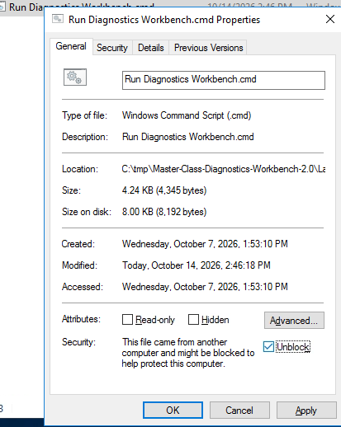
Example: Run Diagnostics Workbench.cmd properties with Unblock selected. The same steps apply to this tool's .cmd launcher.
- Click Browse next to Data Folder. Select the C:\Users\Administrator\Desktop\BigFixSrc\Master Class Diagnostics Workbench\SampleData\BigFix Master Class 2026\Result folder. The Workbench now reports "Data Found for 3 of 3 modules".
- Leave the Output Folder at C:\Users\Administrator\Documents\Master Class Diagnostics. A timestamped run folder is created there.
- Enter a Run Name such as MC Lab Exercise. Any name works. The run folder and every output file use it.
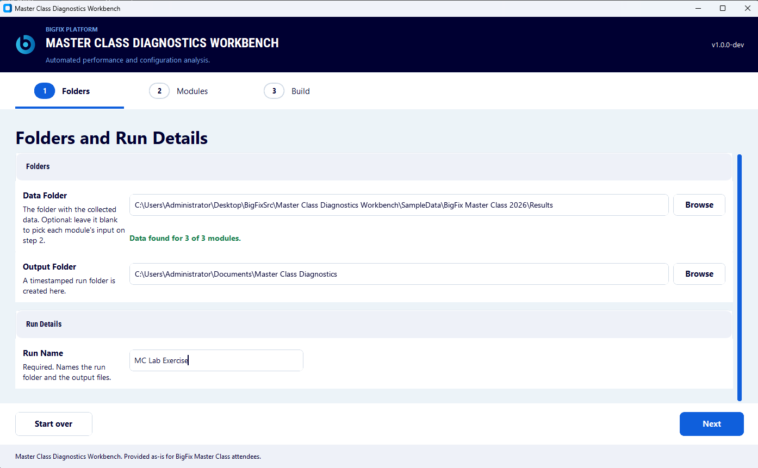
- Click Next. The Choose the Modules to Run page opens.

Step 2: Choose the Modules
- The page opens with every module selected. Click Clear. Select both Client Performance Analysis and Perfmon Infrastructure Analysis. Both rows will show Needs Review until you fill in their details.
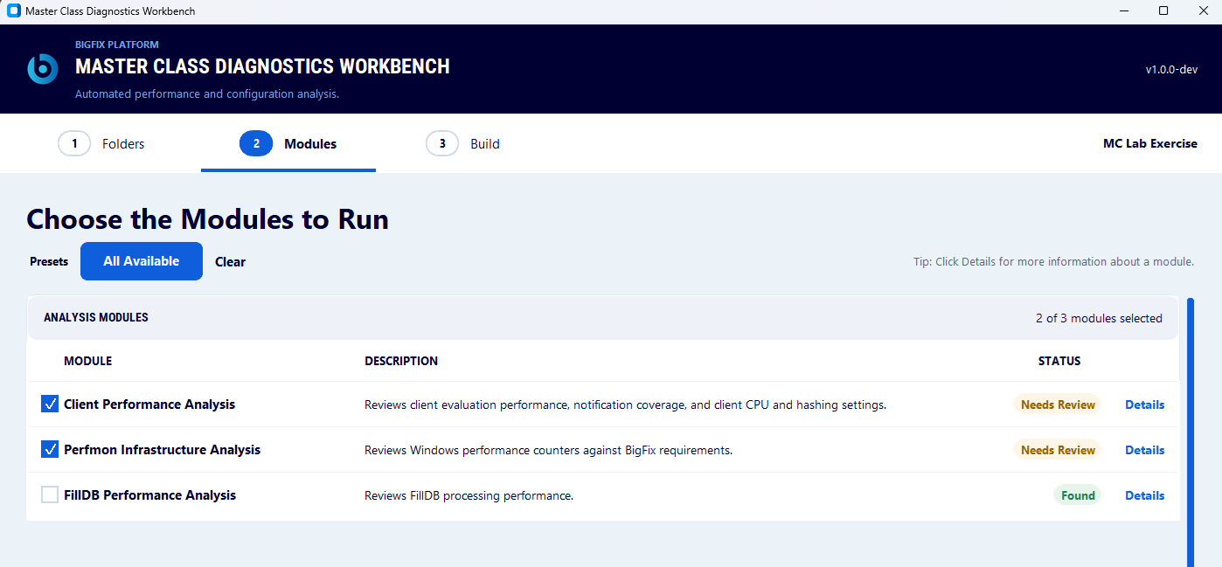

- Click Details on the Client Performance Analysis row. Enter a Report Start Date and a Report End Date. Any dates work. The report shows this range. The row changes to Found.
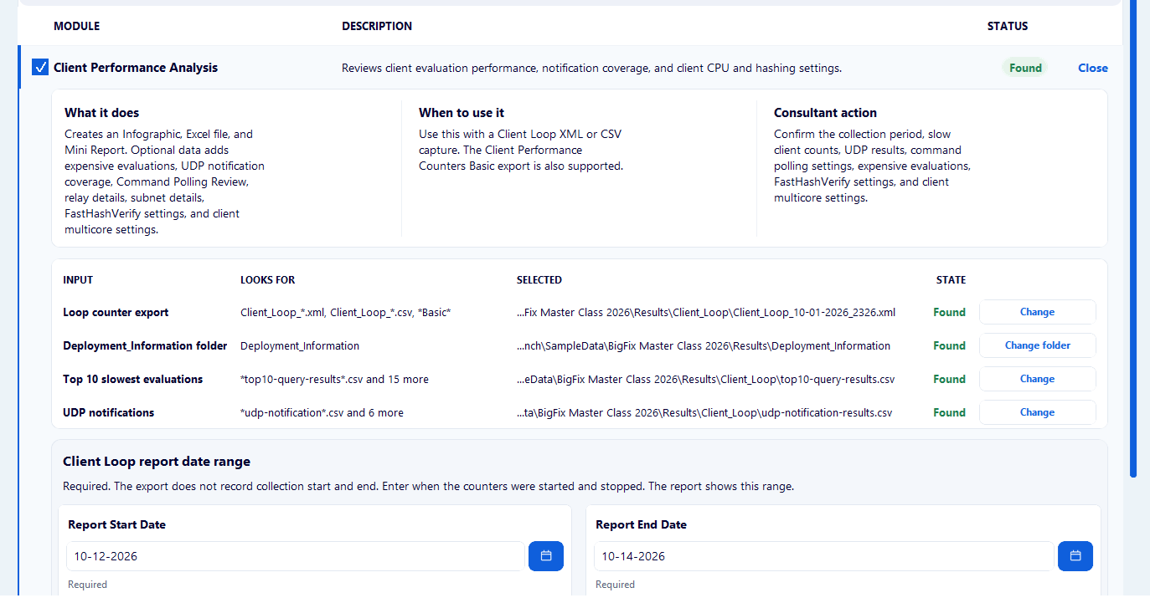

- Click Details on the Perfmon Infrastructure Analysis row. In Capture 1 enter 12 in RAM. Select Virtual machine. CPUs and Disks are read from the .blg file capture. The row changes to Found.
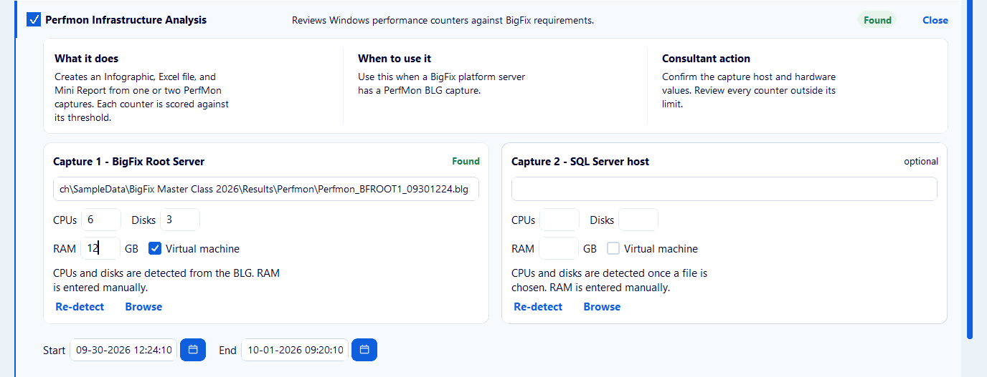

NOTE: RAM is not in the Perfmon capture. Without it the Memory Health counter (PRF-INF-09) is not scored.
- Click Next. The Build the Outputs page opens.

Step 3: Build the Outputs
- Check the Run Details. Click Build.
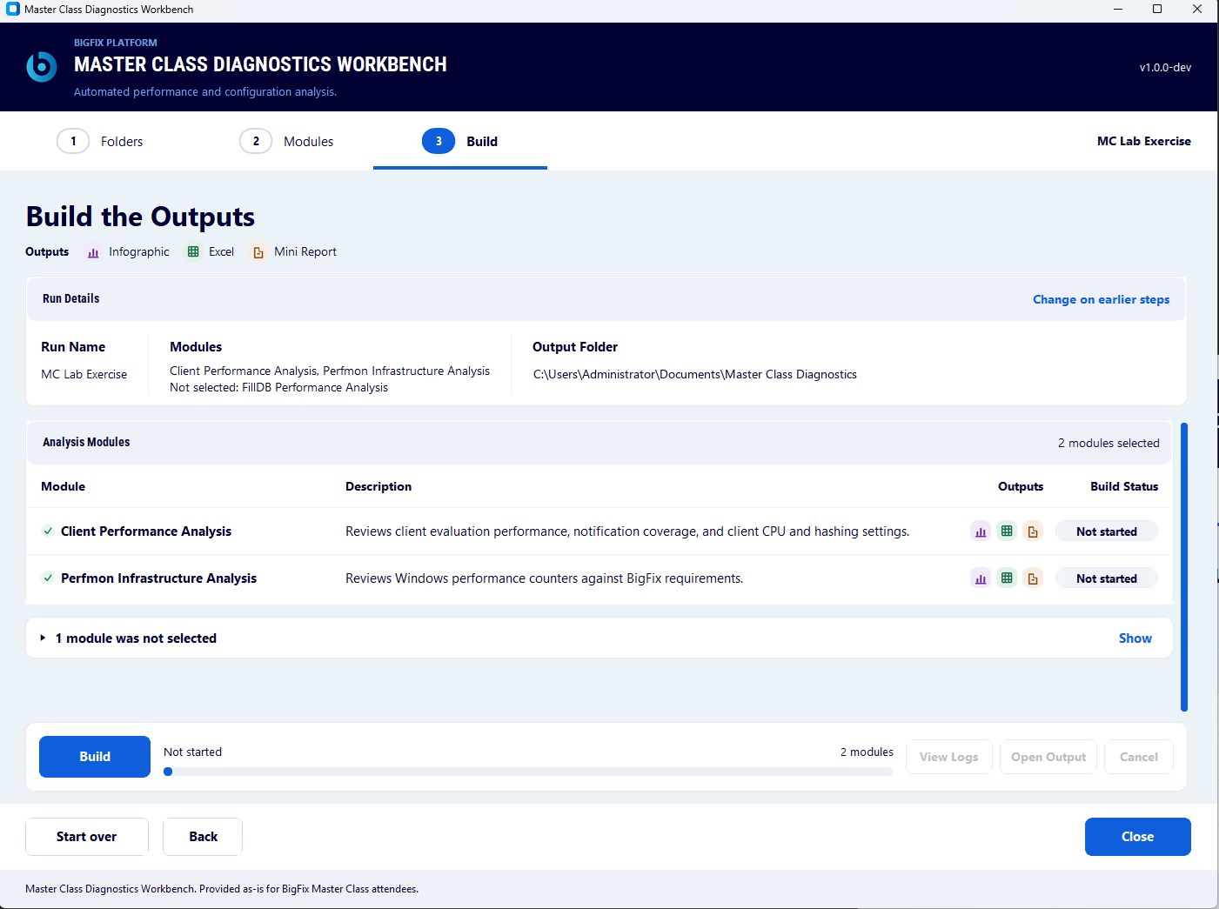

- Wait for the Build Status of each module to change from Not started to Running to Done. You can monitor the status of the build in more detail by clicking on View Logs.
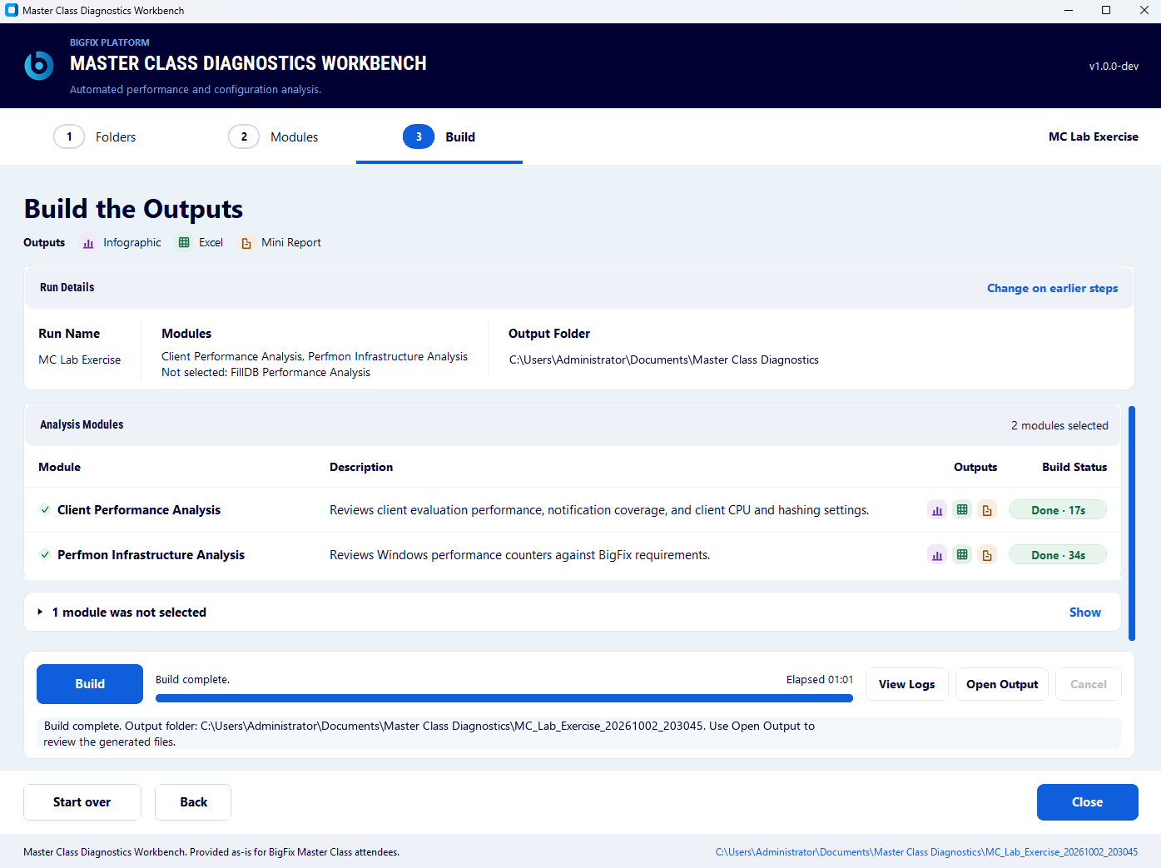

- Click Open Output. The run folder opens. It holds a folder for each module along with the run logs.
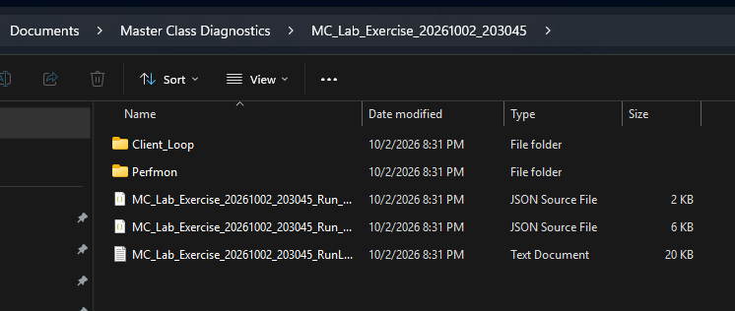

You have now successfully completed Exercise 2.

Exercise 3: Read the Client Performance Output
In this exercise, you will read the Client Performance outputs. Each Workbench module writes a Mini Report, an Infographic and an Excel workbook.
- Open the Client_Loop folder at C:\Users\Administrator\Documents\Master Class Diagnostics\<run name>_<date>_<time>\Client_Loop
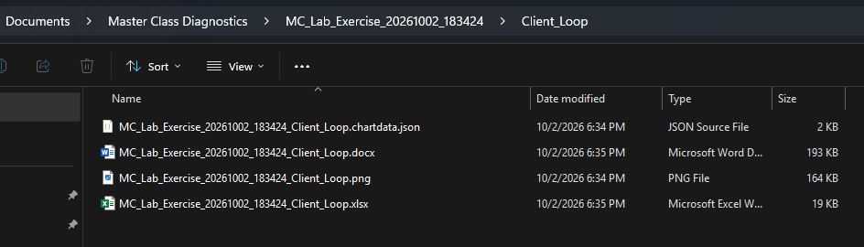
- Open and review the Mini Report .docx as well as the Excel workbook to see what data is available. Discussion questions will be presented to class.
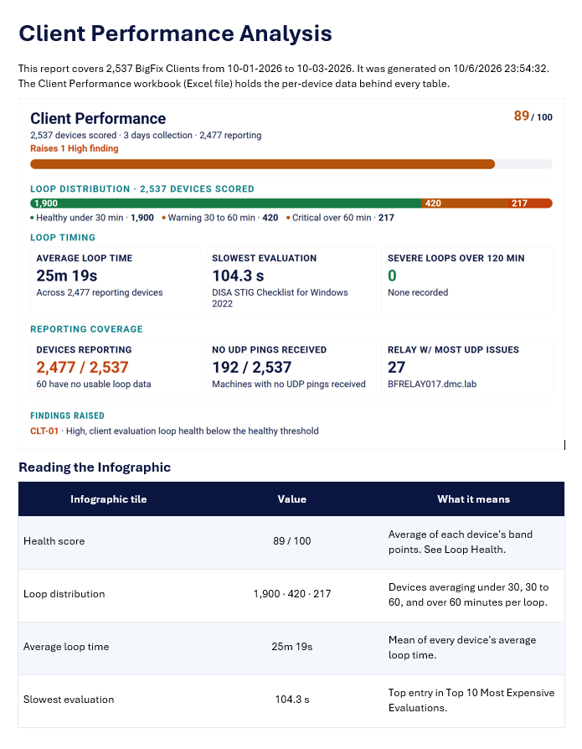
You have now successfully completed Exercise 3.

Exercise 4: Read the Perfmon Analysis Output
In this exercise, you will review the Perfmon analysis outputs. Each counter is scored against its target in the NFR guide. The NFR guide standards and thresholds are listed below for your convenience.
- Open the Perfmon folder C:\Users\Administrator\Documents\Master Class Diagnostics\<run name>_<date>_<time>\Perfmon
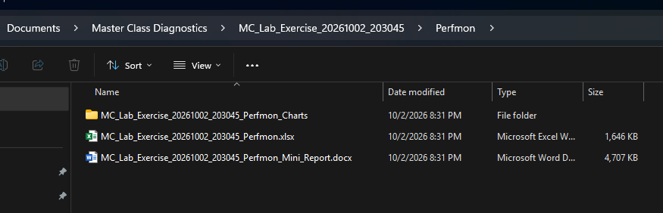
- Open and review the Mini Report .docx as well as the Excel workbook to see what data is available. Discussion questions will be presented to class.
The link to the source document is BigFix Non-Functional Requirements: A Checklist Approach, v11.x.4.

ID | Area | Performance counter | Standard
PRF-INF-01 | Storage Queue Depth | Physical Disk: Current Disk Queue Length | ≤ 1 per physical device
PRF-INF-02 | Storage Latency | Physical Disk: Avg. Disk sec/Transfer | ≤ 1 ms per physical device
PRF-INF-03 | Storage Operations | Physical Disk: Disk Transfers/sec | No saturation under load. DBMS storage supports 5,000 transfers per second.
PRF-INF-04 | CPU Utilization | Processor: % Processor Time | Virtual: 50% to 80%. Physical: ≤ 80%.
PRF-INF-05 | CPU Latency | System: Processor Queue Length | ≤ 4
PRF-INF-06 | CPU Privileged Time | Processor: % Privileged Time | ≤ 10% of aggregate CPU
PRF-INF-07 | Network Health | Network Interface: Packets Outbound Discarded, Packets Outbound Errors, Packets Received Discarded, Packets Received Errors | All counters approach zero per interface
PRF-INF-09 | Memory Health | Paging File: % Usage Peak | ≤ 5% of aggregate physical memory
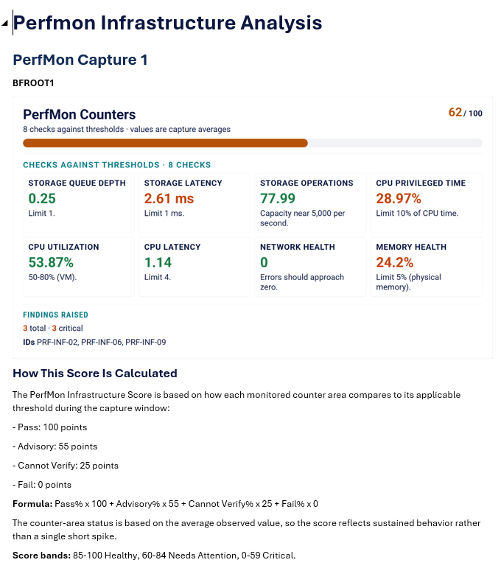
You have now successfully completed Exercise 4.

Appendix A: FillDB Performance (Bonus Round)
FillDB is not part of the live lab. Run it if time permits or after the session. The sample data includes a FillDB analyzer CSV, so you can run the module without collecting logs. FillDB Performance Analysis reviews how quickly the root server processes client reports.

Collect the logs
- In the Performance and Config Analysis site select BigFix Master Class -- Enable FillDB Performance Logging (2.0).
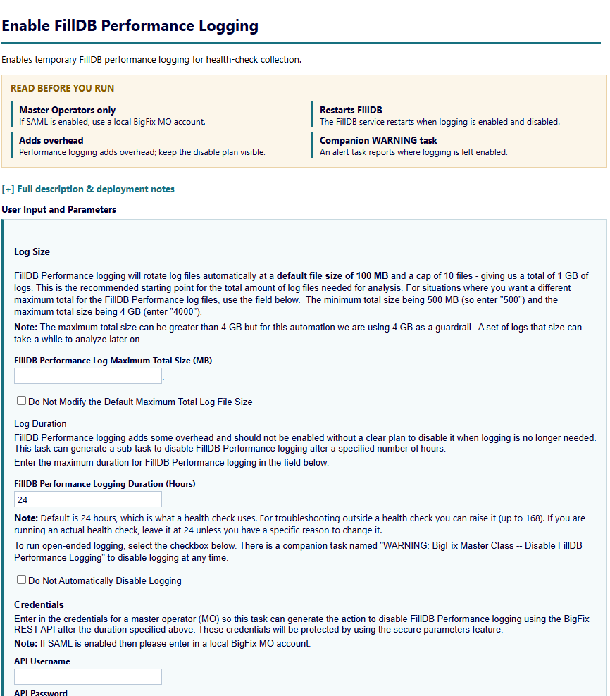
- Enter the console user name in API Username. Enter the console password in API Password and Confirm Password. Keep the default duration.
Username: adminmo
Password: B1gfixrocks
- Click Take Action. On the Target tab select BESFNDWINROOT. Click OK.
- Logging stops on its own after the default 24-hour duration. If you selected Do Not Automatically Disable Logging, run WARNING: BigFix Master Class -- FillDB Performance Logging is Enabled (2.0) to stop it.
- FillDB writes FillDBPerf.log and its rollover files to C:\BigFix_Master_Class\Platform\Results\Logs\FillDB_Performance on the root server.

Run the module
- Run the Workbench. On step 2 click Clear and select FillDB Performance Analysis. Click Details to check the log. The collection dates are optional.
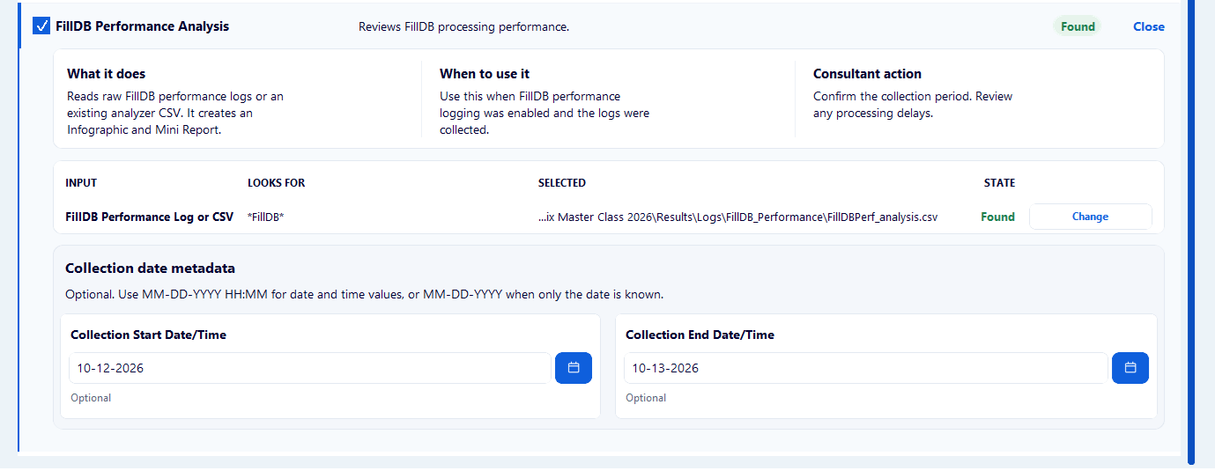
- Click Next and click Build.
- Open the FillDB_Performance folder in the run folder. Open and review the Mini Report .docx as well as the Excel workbook to see what data is available. Discussion questions will be presented to the class.

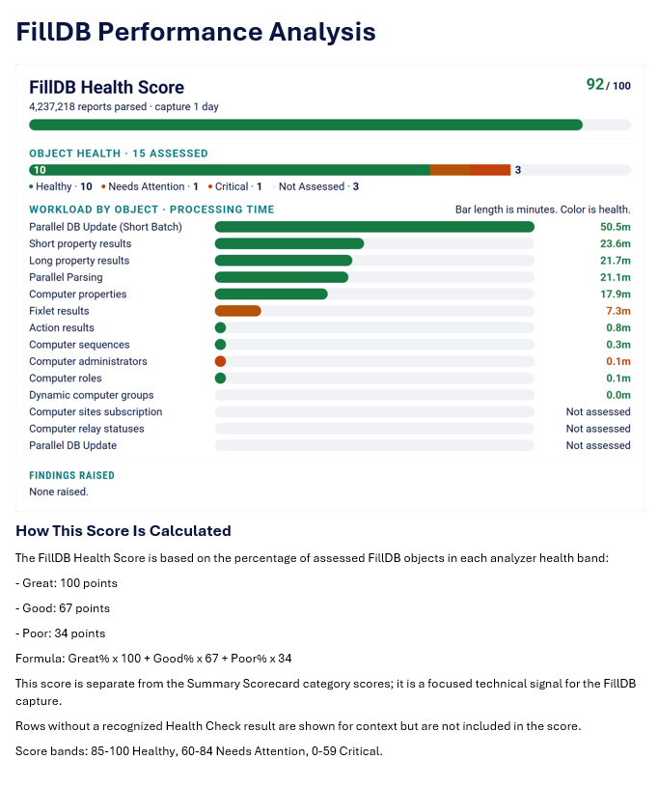
You have now successfully completed this exercise.

